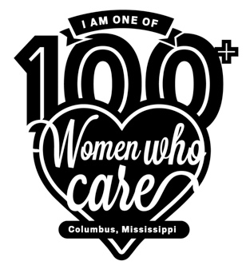

100+ Women Who Care Columbus MS
Registration & Commitment Form

Commitment: With my signature below, I am agreeing that the information I provide below is accurate and true. I am pledging to participate in 100+ Women Who Care Columbus MS, and I am making a personal commitment to contribute $100 twice a year to be distributed to local nonprofit organizations serving Columbus and Lowndes County. I agree to donate to the nonprofit organization selected by the group’s vote. If I am unable to attend a meeting, I will either send my check with another attending member to deliver on my behalf; mail a check to 100 WWC Columbus MS, P.O. Box 1242, Columbus, MS 39703, or donate using PayPal. MAKE ALL CHECKS PAYABLE TO 100 WWC COLUMBUS MS.

I understand my personal contact information is strictly confidential, and I understand it will not be shared or distributed to an outside third party without my expressed consent. I also acknowledge that photographs and videos taken at events and meetings may include my image and may be used in promotional materials for 100+ Women Who Care Columbus MS.

Member:

First Name____________________________ Address__________________________________

Last Name ____________________________ City_________________ State _____ Zip______

Best Phone # __________________________ Email Address_____________________________

Date_________________________________ Signature_________________________________

Please circle the best way to contact you: email best phone #

Completed Commitment Forms may be sent via e-mail to 100wwc.columbusms@gmail.com or forms may be completed and turned in at a meeting. A copy of this form may be found on our website – www.100wwccolumbusms.org (Should you wish to discontinue membership at any time after your yearly commitment, please send an e-mail to 100wwc.columbusms@gmail.com indicating your withdrawal.)

revised 9/2020

